

**UGANDA NATIONAL EXAMINATIONS BOARD**

**ASSESSMENT MANAGEMENT INFORMATION SYSTEM (AMIS)**

**MANUAL**

**PRESENTED BY**

**TEACHER TRAINERS UNEB**

**13th - 24th Nov 2023**

**INTRODUCTION**

The Ministry of Education and Sports rolled out a competence-based curriculum at the lower secondary level in 2020, that requires all secondary schools to submit Continuous Assessment Scores to the Uganda National Examinations Board. To enable a smooth and timely transfer of Continuous Assessment Information between the Board and schools, the Uganda National Examinations developed the Assessment Management Information System (AMIS).

The AMIS has two sub-systems; the desktop system and the web portal system. These tools enable the schools to capture continuous assessment information regarding the learners’ registration details, and their scores or achievement, as well as submit the data to UNEB.

### 1. SOFTWARE AND SYSTEMS REQUIREMENTS

For any **School / Centre** to use the **UNEB** Assessment Management Information System (AMIS), the following are required:

1.1 A working computer (Laptop or Desktop) with:

* Windows 8 or higher versions
* Microsoft .NET Framework 4.8 or higher versions
* At least 2GB (RAM) of Memory
* Microsoft Office Installed

1.2 Internet connection

*With Internet user* centers/schools can register, assess and submit learner’s achievement directly to the board using the Web portal.

A school/center using the desktop to register and assess learners can save the **File and** send/upload it to the board through the web portal using the internet.

# 2. THE ELECTRONIC TOOLS AND THEIR USAGE

The AMIS consists of;

i) the Desktop Tool

ii)the UNEB Web Portal

## 2.1 **The Desktop Tool**

This tool enables schools to collect Continuous Assessment information regarding school and learners’ information (registration) and learners' achievement (Subject score, Project score, and School Based Assessment scores).

### **2.1.1 Installation of the Desktop Tool**

The Desktop Tool shall be installed on a desktop computer or laptop.

To install the desktop tool application, make sure the target computer has the software and system requirements. (refer to section 1.1 of the user manual).

1. Insert the **flash disc** into the drive and follow instructions to install
2. Double click the setup.exe file as shown in the image below (*i.e.* setup ......

application)

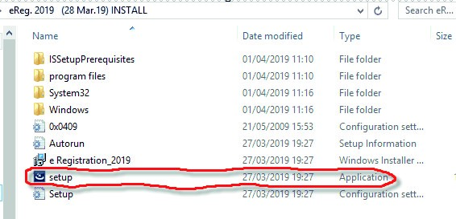

1. **'accept'** > click '**next/install**' depending on what shows on the window that opens. Eventually, click '**Finish**'.

**\*** The **installer** creates a shortcut (*below*) on the **desktop** and you are able to start using the application.

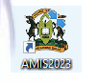

(*double click on the icon*)

A new window opens showing the screenshot below:



(*double click on the CA tab seen above*)

A drop down menu shall open showing the screenshot below:

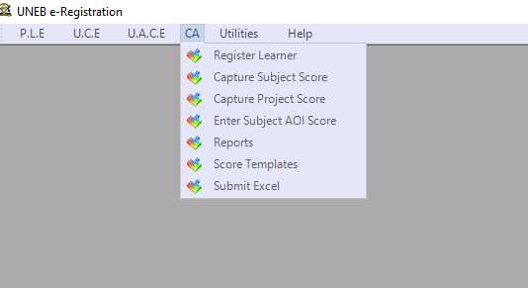

### 2.1.2 Registration of Learners

Registration is the process of capturing authentic learner’s details in a particular school on the CA Information Management System provided by UNEB. The information to be captured includes; **School information, PLE details or equated code/adult code, learner’s details, and subjects offered.**

To capture the learner’s details, click the CA menu and choose register learners. The screen will display the page for filling learner’s details as shown below.

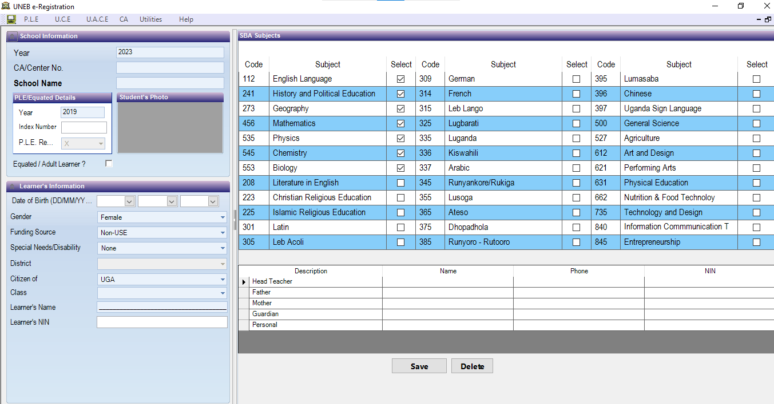

1. Enter your school ID (Center/CA number) and the learner's PLE index number.
2. The system automatically generates the learner's name, date of birth, and the district.
3. Fill in the remaining details namely, the learner’s class, SNE, and parents.
4. Select the subjects to be offered by the learner.
5. Once all the details of a particular learner have been captured, click **Save.** The system automatically generates a student ID.
6. Repeat the procedure until all the learners are registered.

## **2.1.3 Capturing learner’s achievement records**

### **2.1.3.1 Subject Competences**

To capture the learner’s achievement records, click the **CA** menu and choose **Capture** **Subject Score**. The screen will display ‘School Details’ and the ‘Competency-Based Assessment’

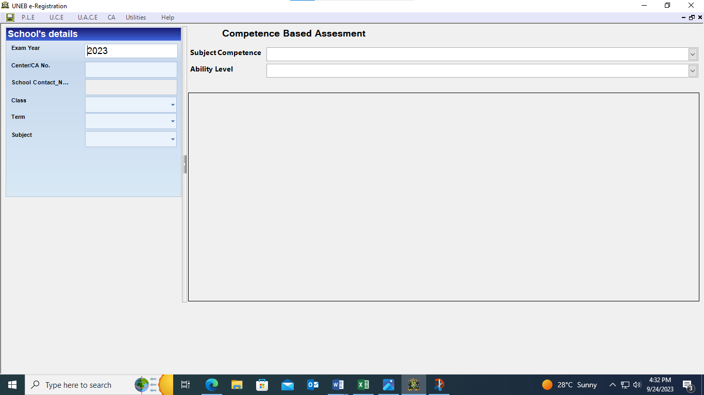

1. Enter the school ID and select the class, term and subject
2. Under competence-based assessment select **subject competence** and **the ability level** to be captured. The system automatically displays a list of learners registered for that subject, whose scores should be captured.

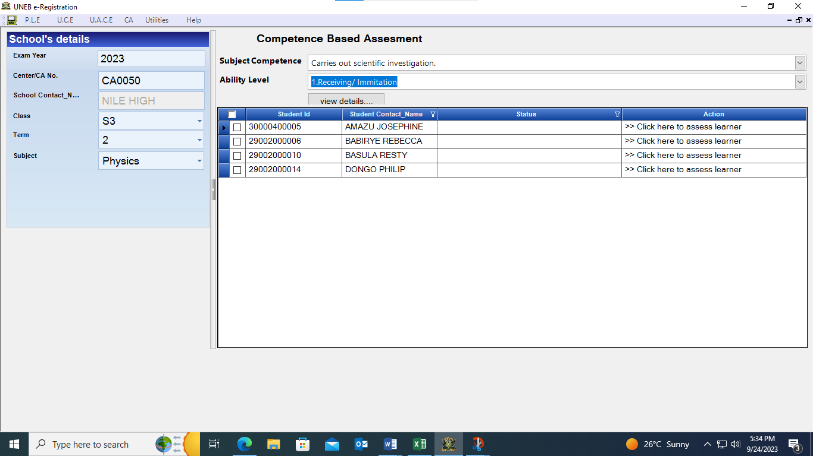

1. Click **“click here to assess learner”,** the screen will display indicators for both the subject competence and generic skill as per the ability level to be captured.
2. Check only the indicator (s) that you have observed the learner display at a particular level.
3. Click **Save** and continue to the next learner.
4. Once you have captured data for one learner, go to another learner until all the learner’s achievements have been entered.
5. Proceed to ability levels two, three, four, and finally five to complete the assessment of a given subject /competence for the learners registered.

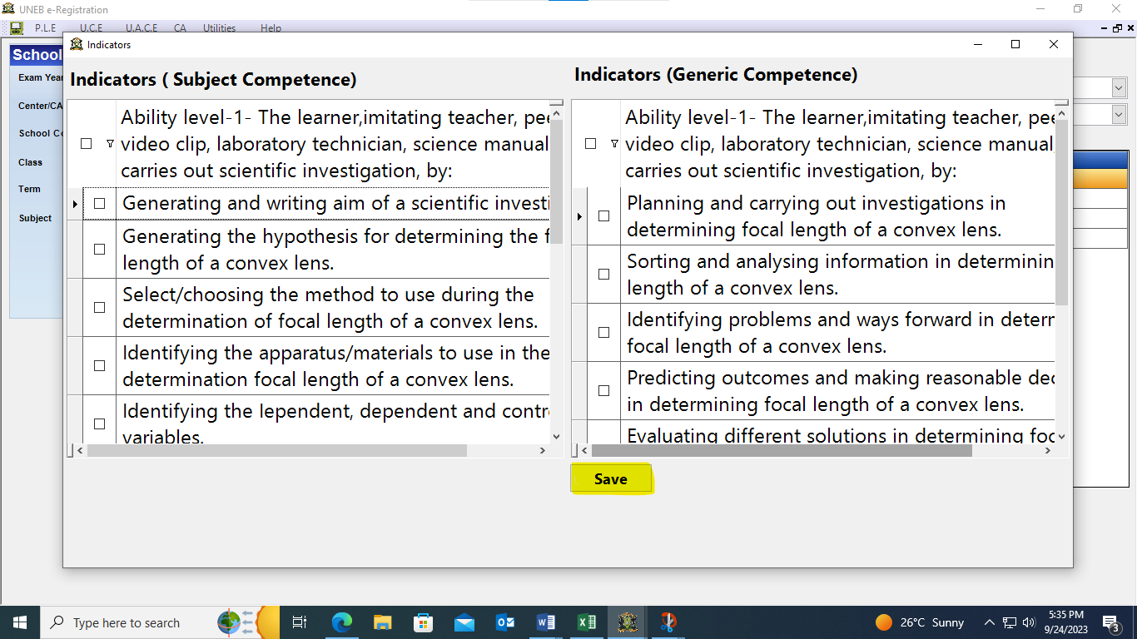

### 

### **2.1.3.2 Capture Project Score**

To capture the learner’s achievement records on projects, click the CA menu and choose **Capture Project Score**. The screen will display school details and the competence-based assessment as shown in

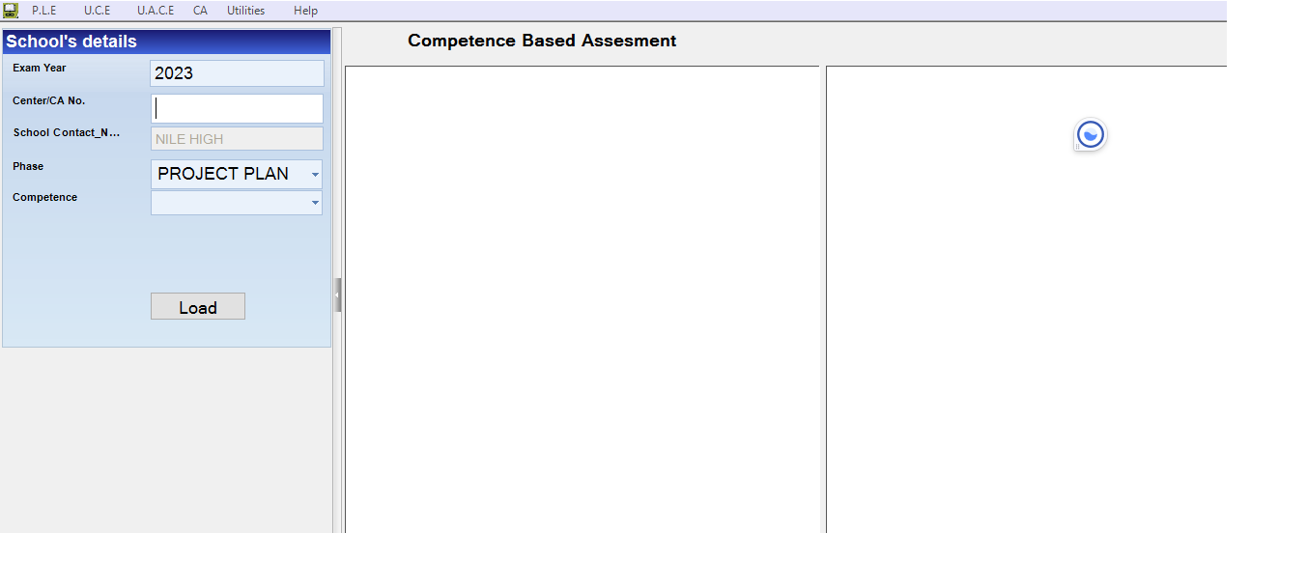

1. Enter your S**chool ID,** and select the **Project phase and the project competence** (One cannot assess and capture the subsequent phase before completing the earlier phase).
2. Click **load;** the system will display the registered learnerswhose project scores are to be captured
3. The system will display the command **“Click here to assess”.**
4. The system will display a list of indicators for that particular project competence.

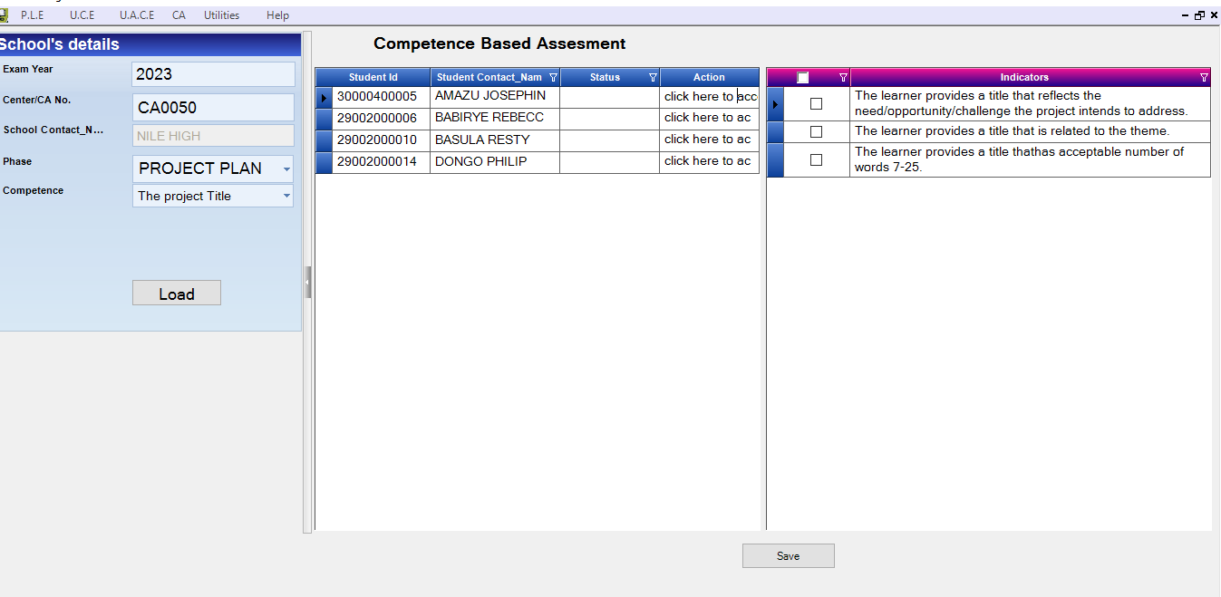

1. Click/ tick in the check box of the indicator that you have observed the learner do.
2. Click **Save** and proceed to the next learner**,** until all the learners have been assessed for each competence

### **2.1.3.3 School Based Assessment (SBA) or Activity of Integration (AoI) Scores**

To capture the learner’s achievement records on SBA/AoI, click the **CA** menu and choose **SBA Score**. The screen will display the figure below.

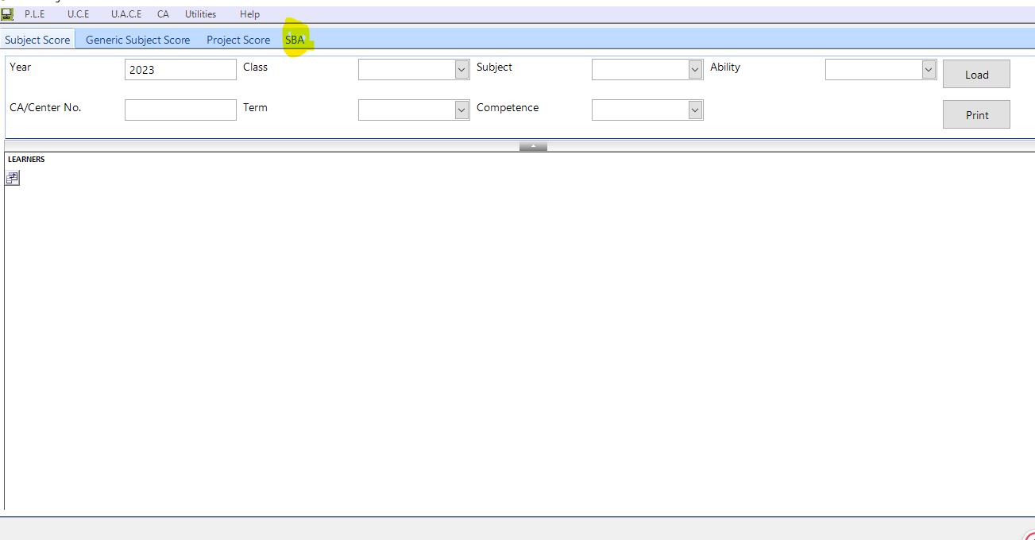

1. Click on **SBA,** and the system will display the year, Centre number or CA number, and subject
2. Enter the year, school ID, class, term, and subject.
3. The system will display all the registered learners and the topics for that term as shown below.

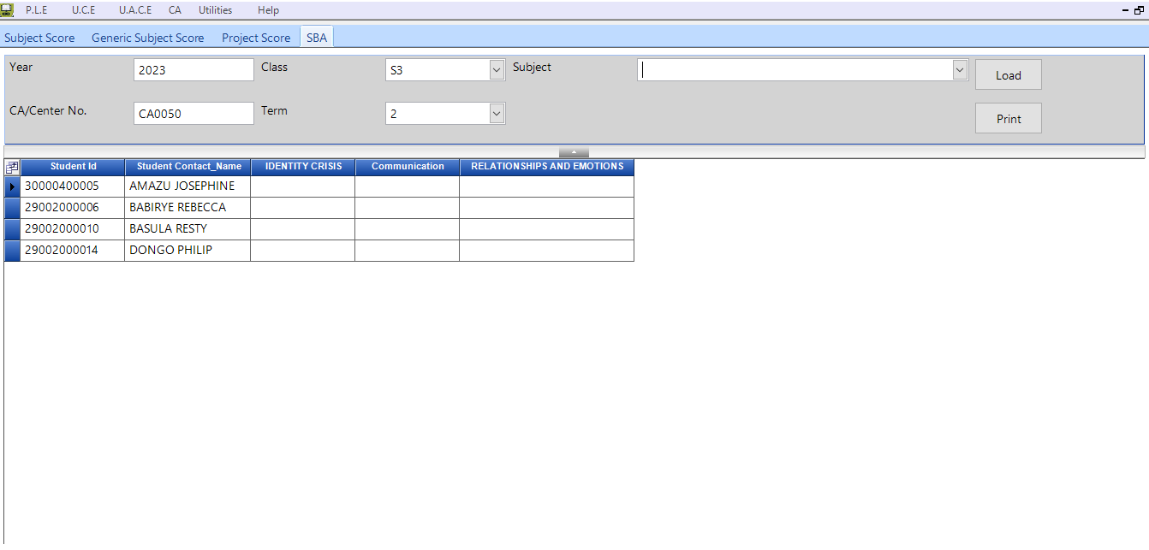

1. Enter **only** the learner's score per topic.

### 2.1.3.4 Reports

The reports on the **AMIS** provide information on the number of registered learners, subjects offered, and the status of data capture regarding assessment in a particular school. The system provides the following reports; **Summary Score**| **Registered Learners** **Report** |**Assessed Learners**.

**Access to the AMIS Reports**

1. From the **CA menu** click **Reports**

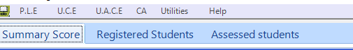

1. Select/ click on the report needed
2. **Summary score report**
3. Click the tab **Summary Score**
4. The system will display the window

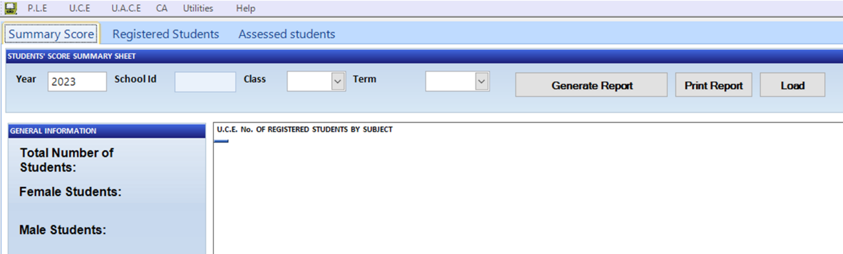

1. Fill in the required areas/ fields (School ID, Class, Term)
2. Click **Generate report** or **Load**
3. The system will display the registration statistics, regarding **gender**, **subjects**, **number of competencies per subject**, **total scores expected**, **submitted scores**, **missing scores** and **teacher’s comment.**

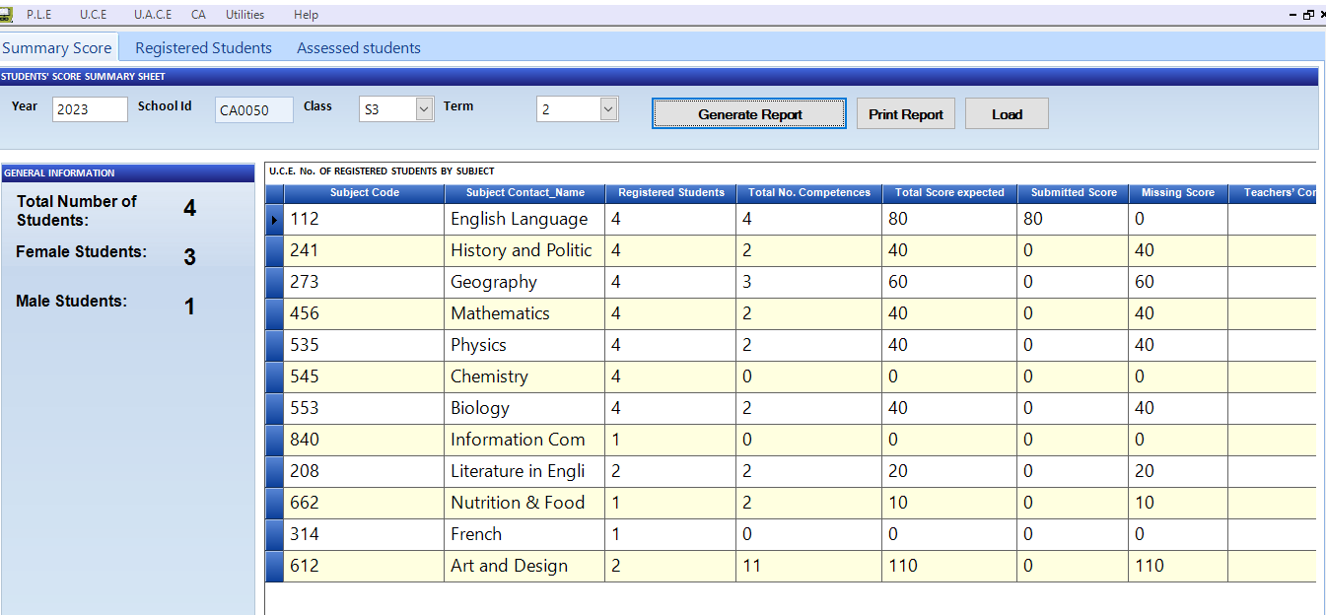

1. **Registered Learners Report**
2. Click the tab **Registered Learners**
3. The system will display the window in the figurebelow

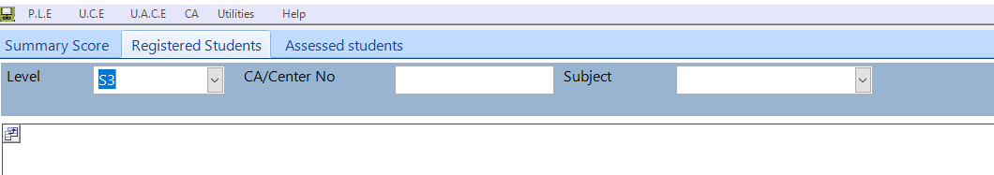

1. Fill in the required areas/ fields (**Level** (for class), **School Id** and **Subject**)
2. The system automatically displays a list of learners (Learner Id), name, gender and date of birth)

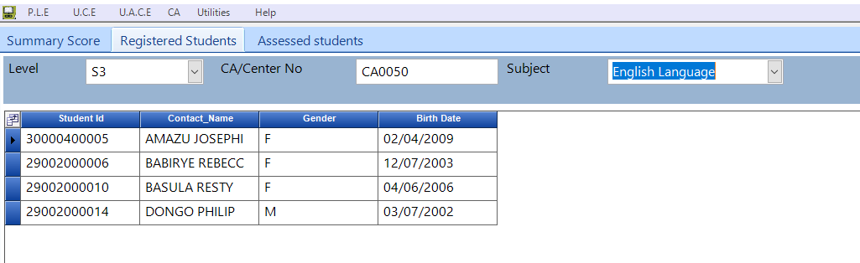

1. **Assessed learners Report**
2. Click the tab **Assessed Learners**
3. The system will display the window

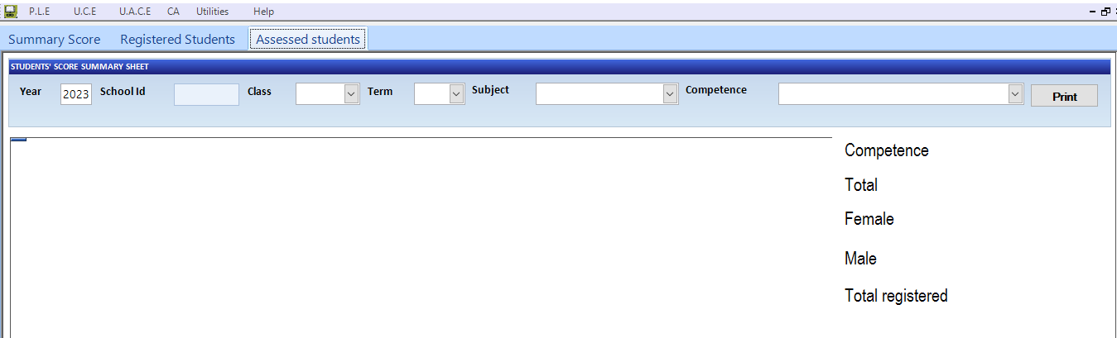

1. Fill in the required areas/ fields (school ID, class, term, subject, competence.
2. The system will display a list of learners that have been scored for every level of ability

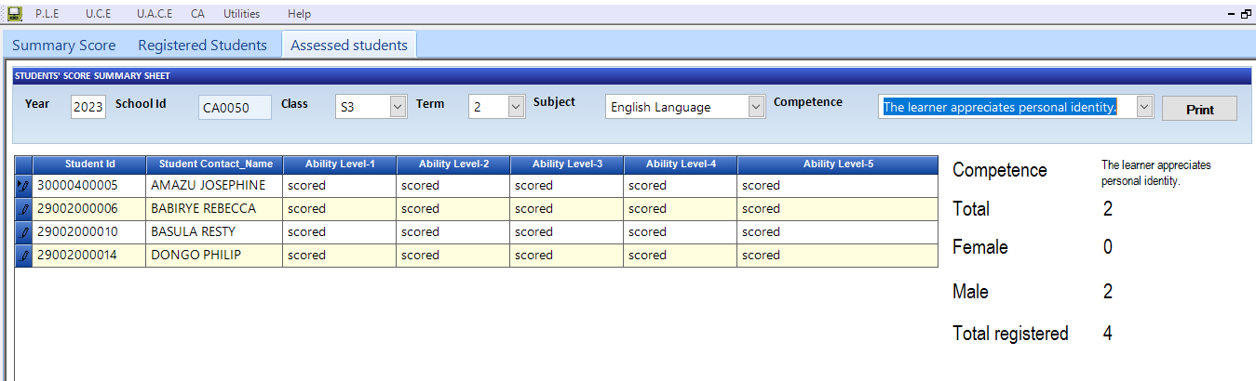

### **2.1.4 Submit Excel**

The **Submit Excel** item on the CA menu provides a summary of all the CA information captured by the school which should be submitted to UNEB via the portal. The information includes; **Learners Details, Subjects offered at the school, Learners contact details, Information on students with special educational needs, CA scores, Cases, Project scores SBA**. This information is automatically generated in an excel files and allows one to view the details before submission to UNEB.

**Viewing and saving the Excel file for upload.**

1. Fill in the required fields namely; **School Id**, **Record type** e.g. student information, scores, SBA project, All).
2. Click **Load**

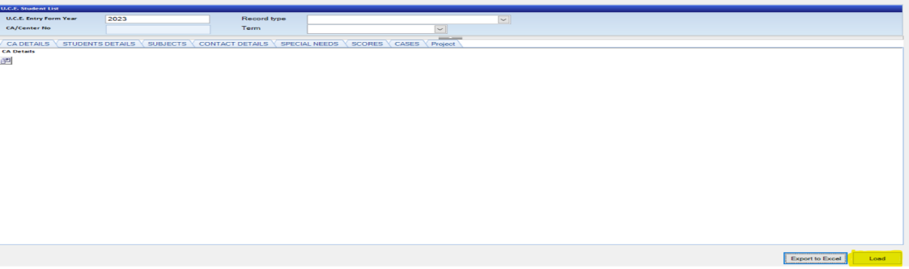

1. Click on each tab to view and verify information captured.
2. Click **Export to Excel** to save the excel file in secure location /folder on your computer.

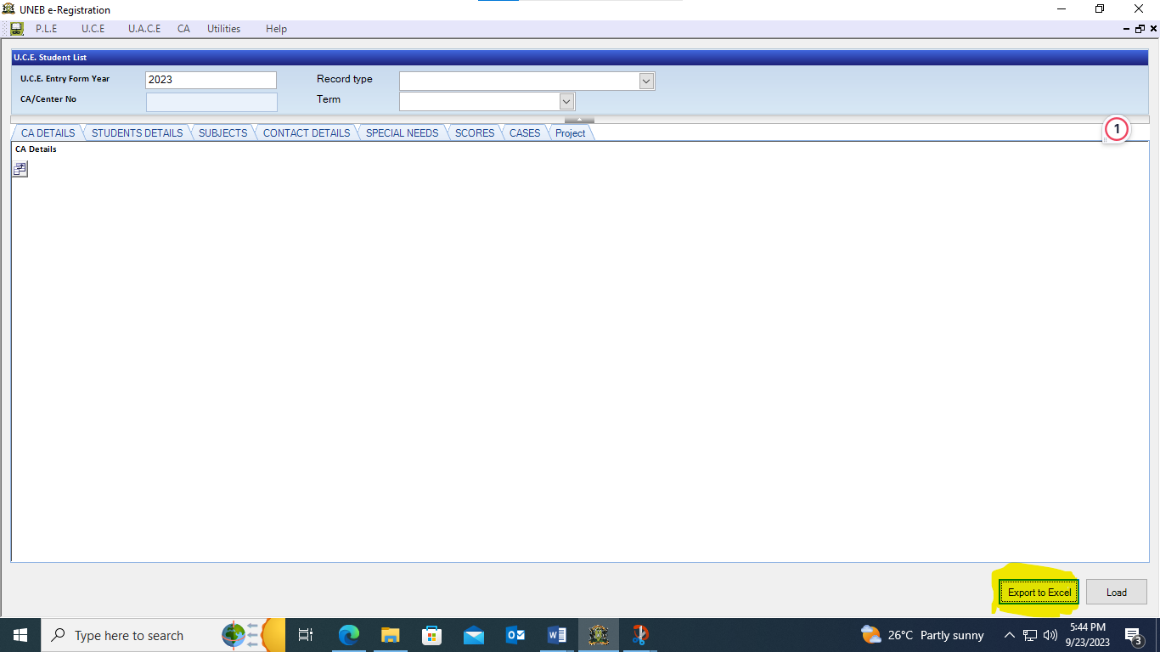

1. Open the saved file in order to ensure that the contents can be viewed and contain the required information.
2. In case the contents of the saved file cannot be viewed or contents are irrelevant, re-save following procedures i) to v).

## **2.1.5 Submission of CA Information to UNEB**

Submission of CA information to UNEB is done through **uploading** the excel file to the Web Portal.

The Web Portal shall be accessed using a link provided by UNEB;

(<https://ca.uneb.ac.ug>):

i) Click on the link and the screen will display:

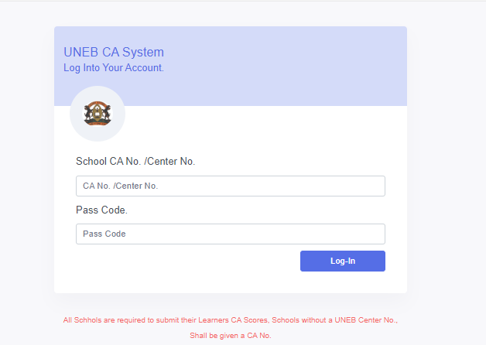

ii) Login using your credentials.

iii) After logging in, the system will display the figure below.

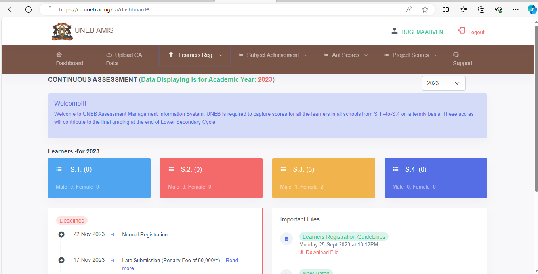

### iv) Click on the **Upload CA data** tab and it will display the figure below.

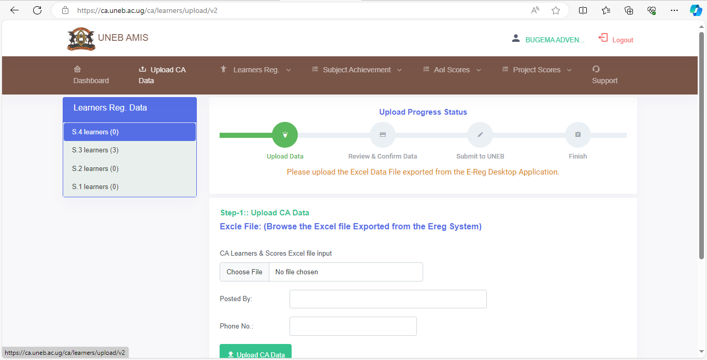

v) Browse the file and upload on the system.

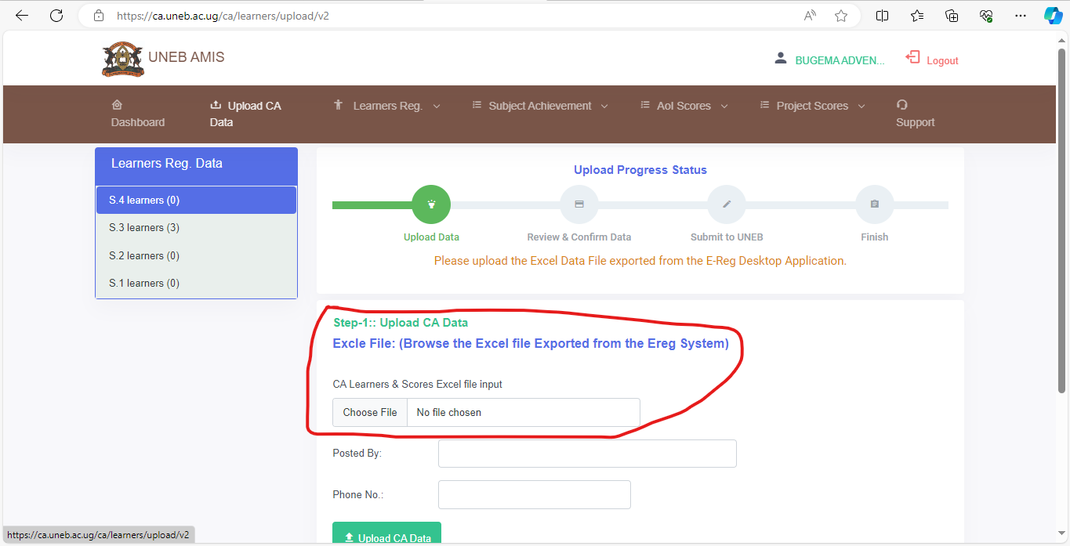

vi) Fill in the required details

vii) Click on **Upload CA Data** and the system will display the figure below.

### 

viii) Confirm that you have uploaded the right data.

ix) Then click **Confirm and Submit** (command in red colour)as shown below.

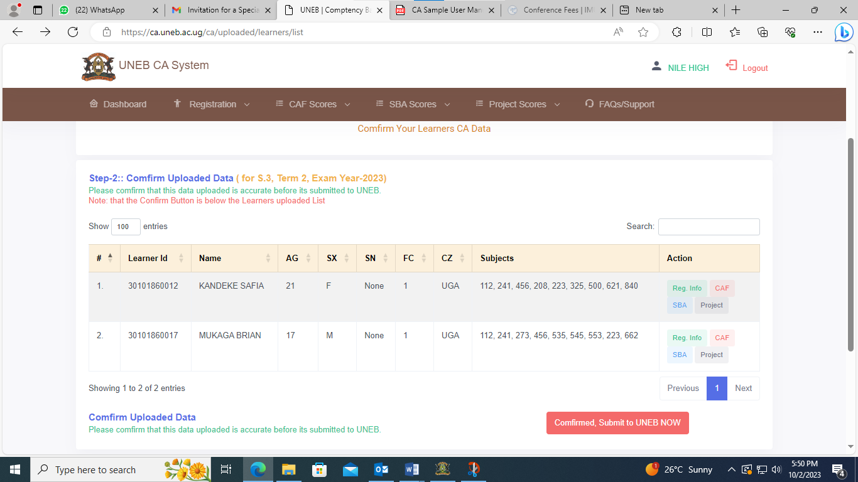

viii) Upon successful submission, the system will display the figure below.



